

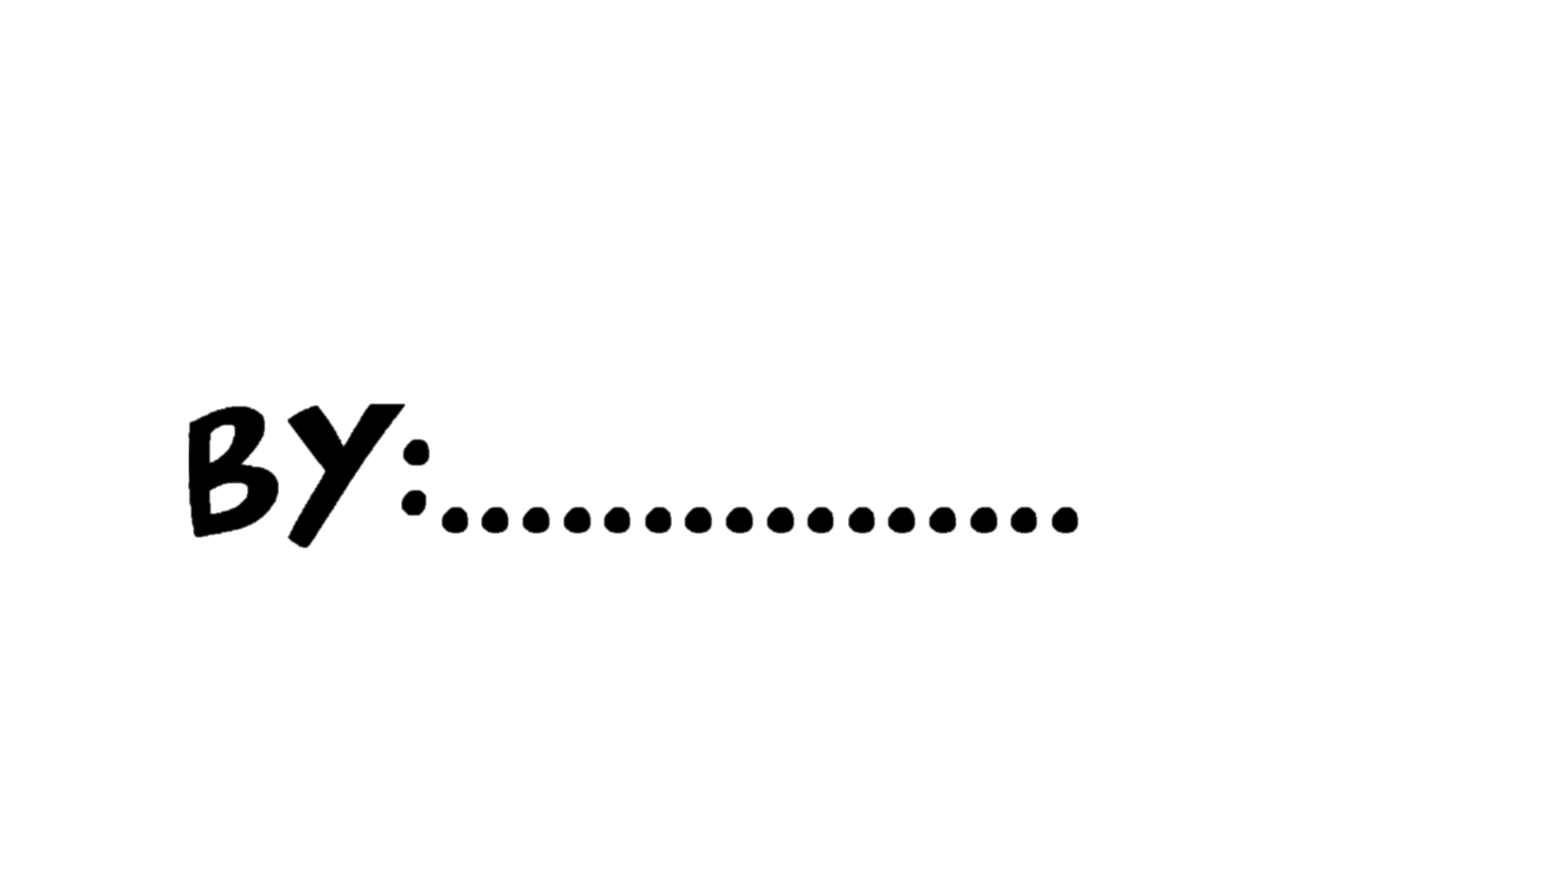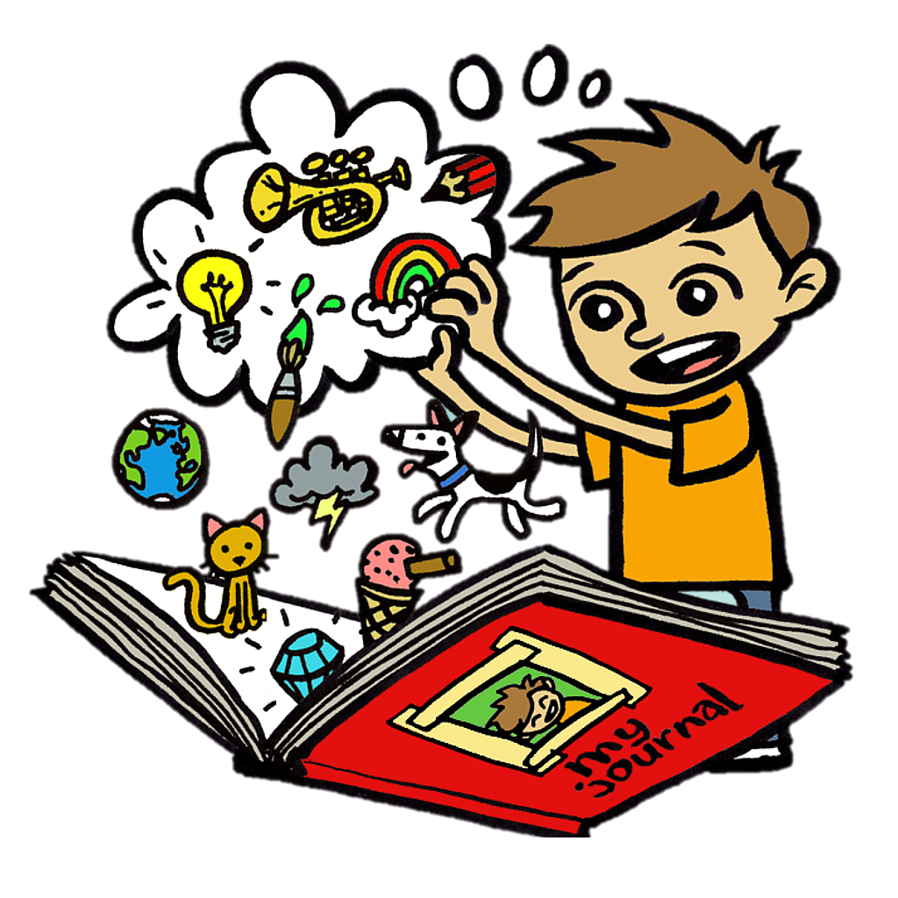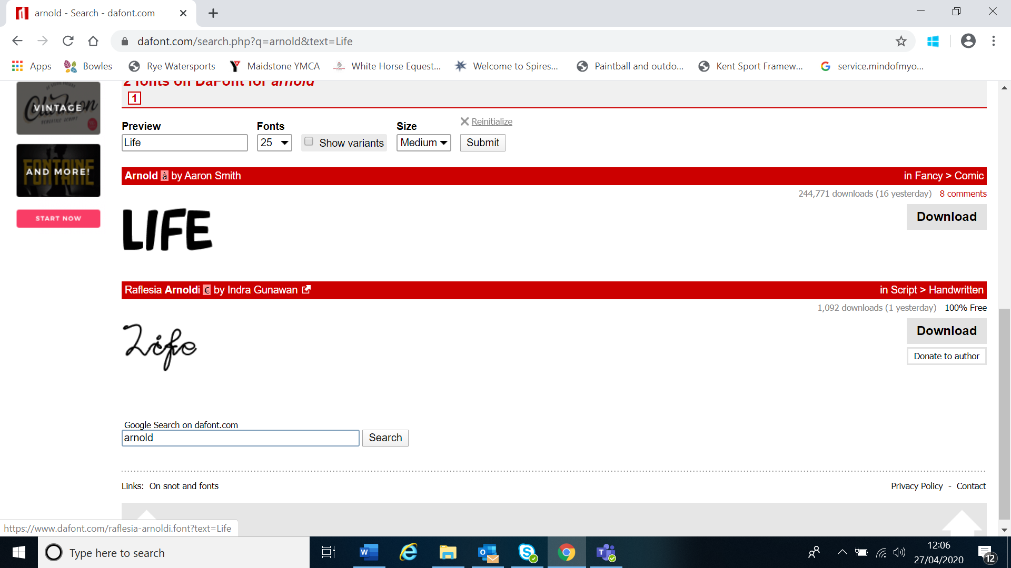









Write, draw or add photographs!

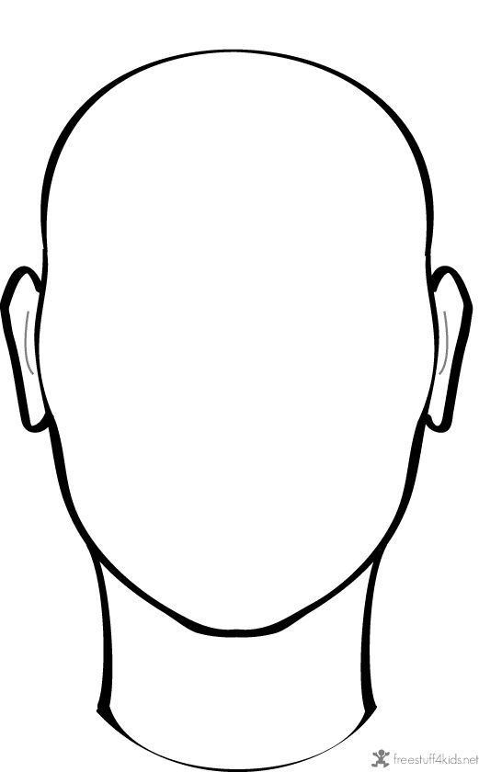

**Words to describe how I am feeling…**

**Things I have found positive…**

**Things I have found more difficult…**





**The support and help I need from adults… are…**

**My favourite memories from this time…**

**My best advice for other young people …**





**New hobbies or activities I will continue after lockdown ends…**

**What I have learnt from this experience…**

**The top 3 things I’m most excited to do after lockdown are…**

3.

1.

2.





**Use this space to write a short story/poem or letter about your time during lockdown. Be as creative as you want!**



If you would like to share your ideas with the Participation Team, email us at [VSK_Participation@kent.gov.uk](mailto:VSK_Participation@kent.gov.uk) or post to VSK, KCC, Worrall House, 30 Kings Hill Avenue, West Malling, Kent, ME19 4AE (just drop us an email so we know to go to collect it!). We would really like to hear about how lockdown has been affecting you and all of the things you have been getting up to during this time.

If you would like a paper copy of this booklet, then email us and we will send one to you in the post!

